Deactivate buyer / procurement staff in Georgia Procurement Registry(GPR)
Step # | Action
1 | Login to GPR. Link: https://ssl.doas.state.ga.us/PRSapp/PR_login.jsp
2 | Click on ‘Main Menu’. (Upper left corner or bottom left corner)  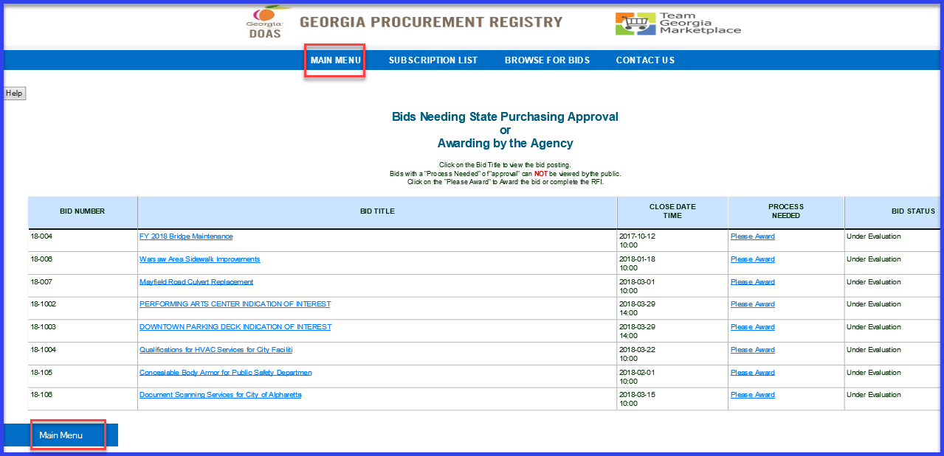
3 | Click on ‘Add Buyer or Procurement Staff Profile’ under ‘Buyer Information’.  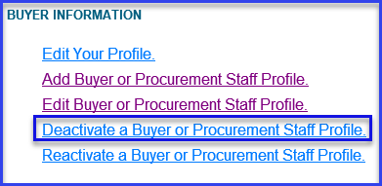
4 | To pull the whole list of users under particular agency, Click on ‘all profiles’ for ‘Type of Profile’ and click on ‘Continue’.  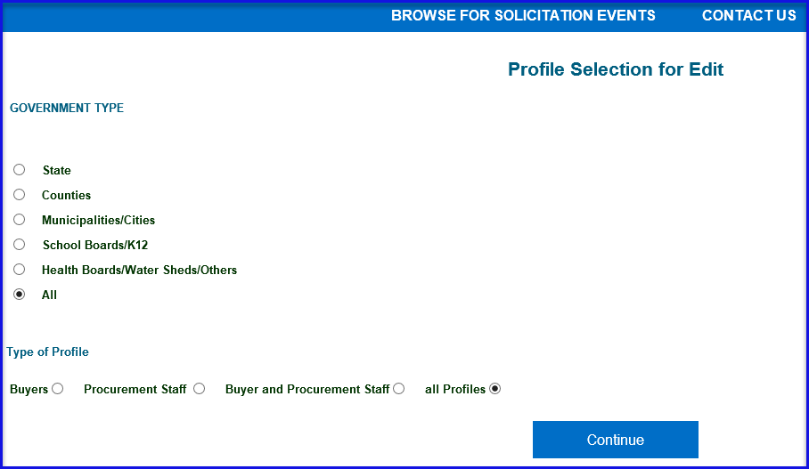
5 | Select button next to appropriate user and click on ‘Delete Profile’.  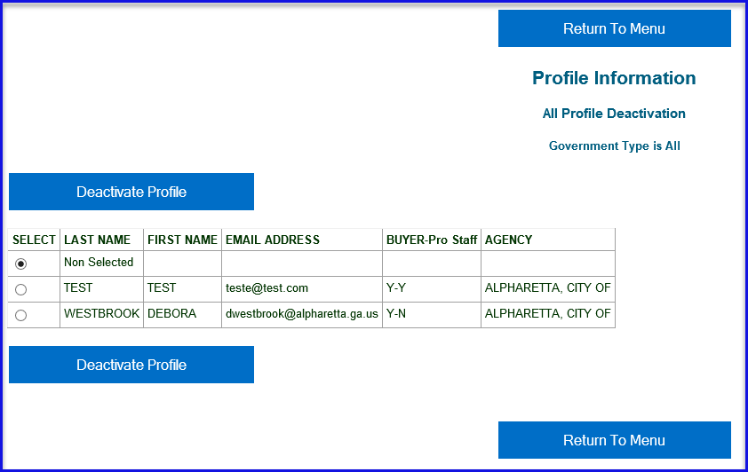
6 | Click ‘OK’ on warning message.  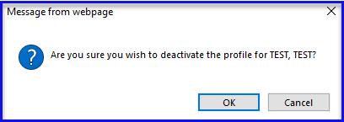
7 | System will show on screen confirmation of deletion.  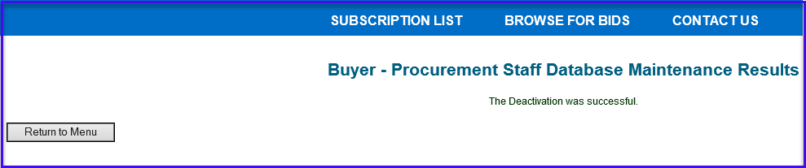
 | End

